Completing Online Activities
Step 1- Go to www.mylearningplan.com
Step 2- Log in
Step 3- Click “Activity Catalogs”
Step 4- Search for course
Step 5- Click on the activity title of the course you would like to complete. (The online activities will have a small cloud underneath the description). 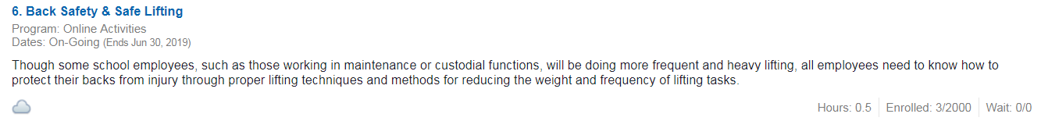
Step 6- Click “Sign Up Now”
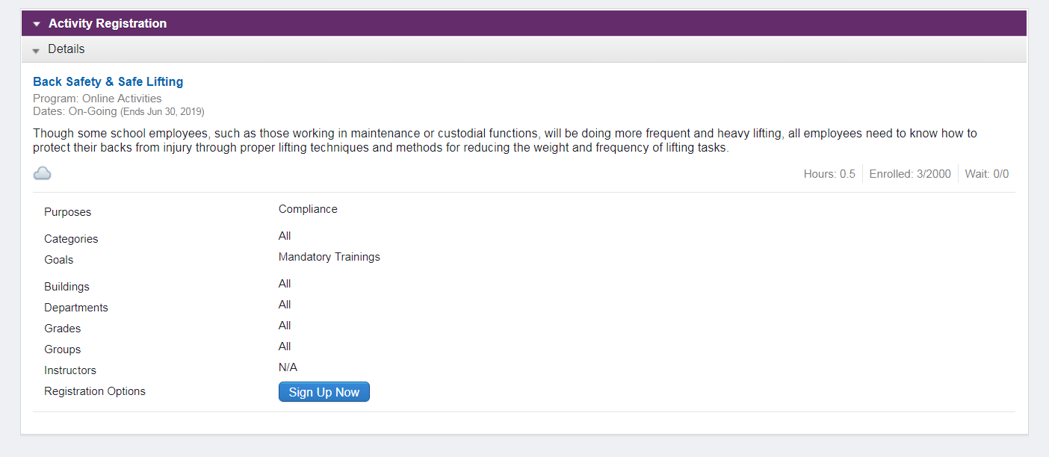
Step 7- Click “Return to Main”
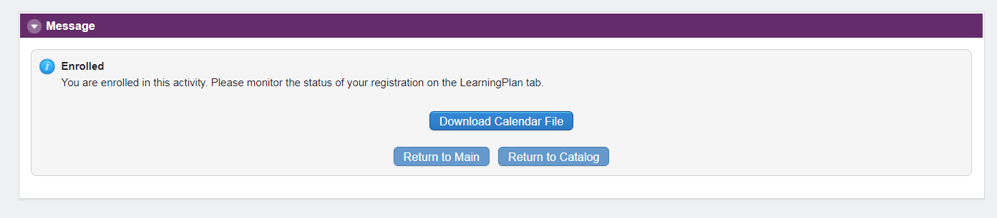

Step 8- To access the course from Learning Plan Click “Manage”
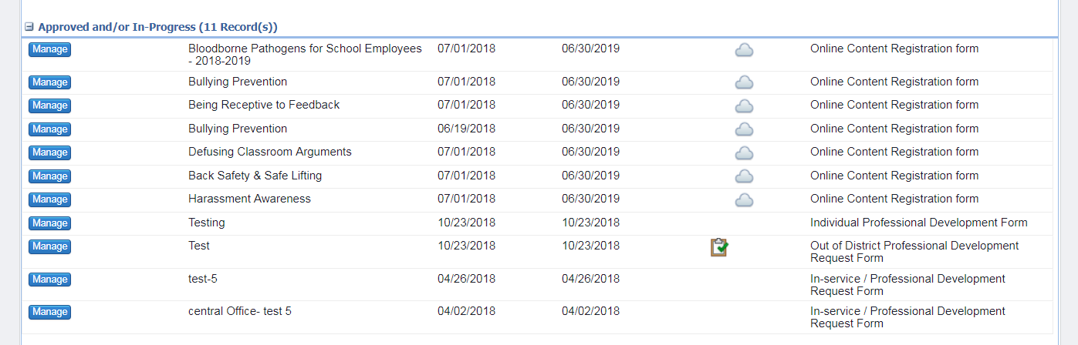
Step 9- Click “Launch Activity”
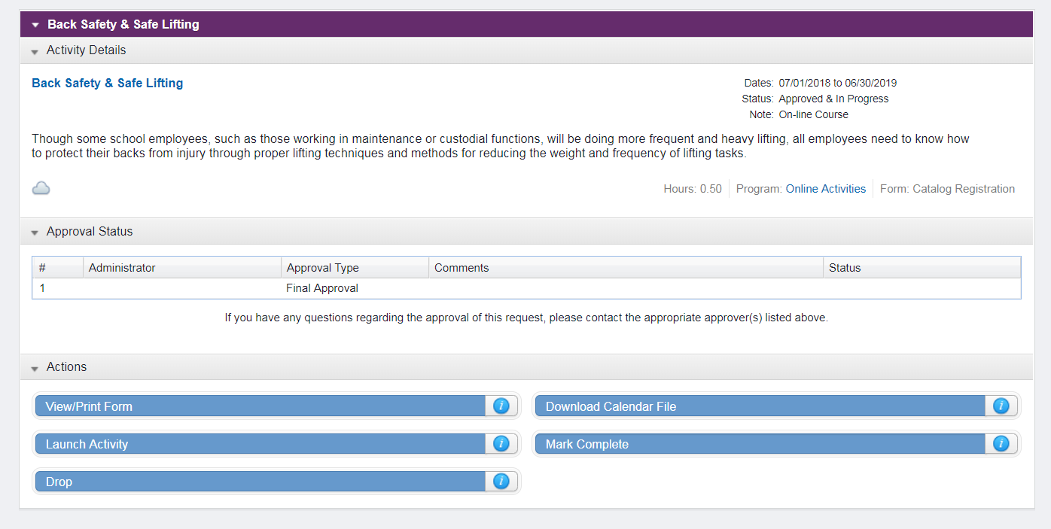
Step 10- Click “Launch”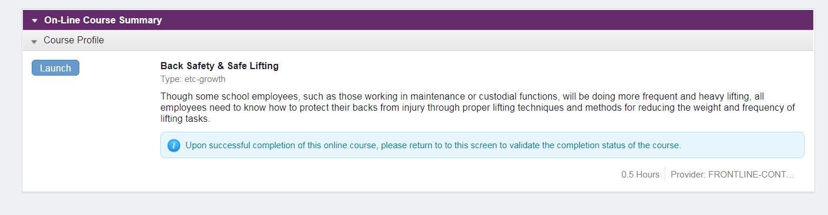

If popup blocked click “Launch Course”
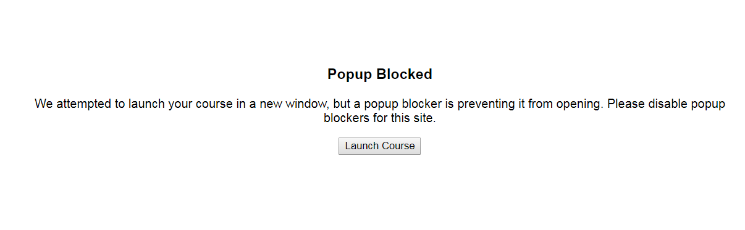
A new window will popup this is where you will watch and complete course
Step 10- If you wish to stop the course and come back to it later, click Exit
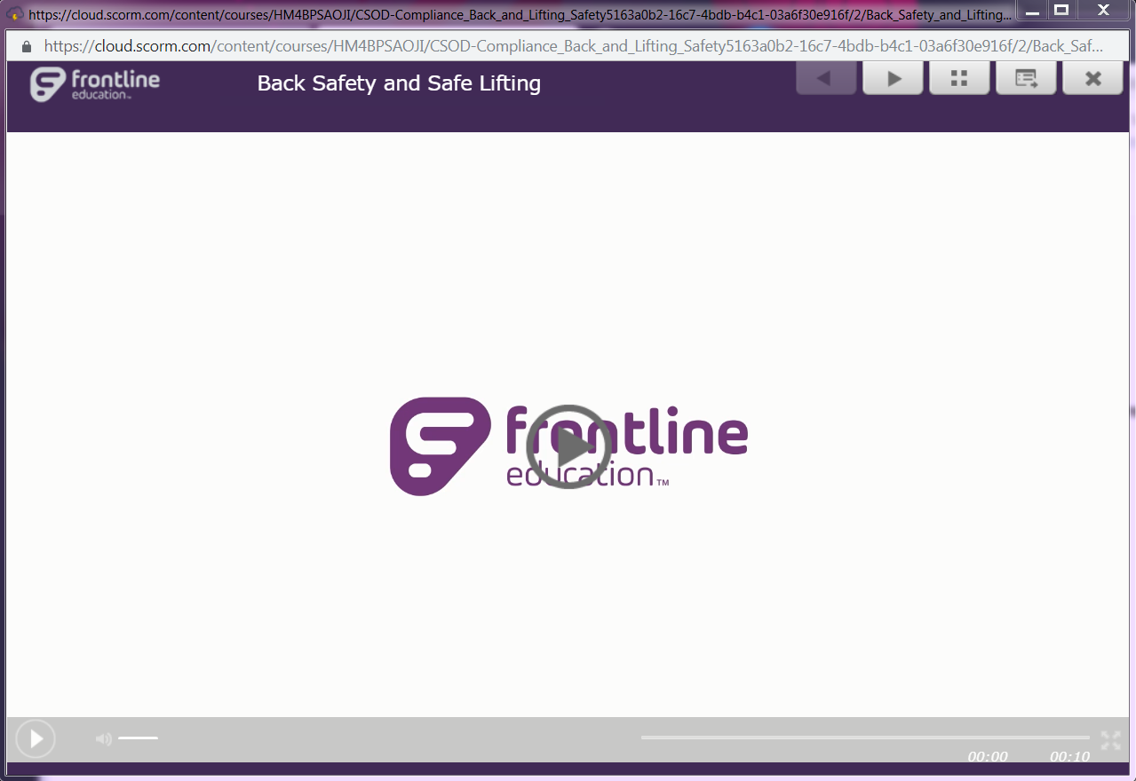

Once you exit the online course you might have two frontline windows open
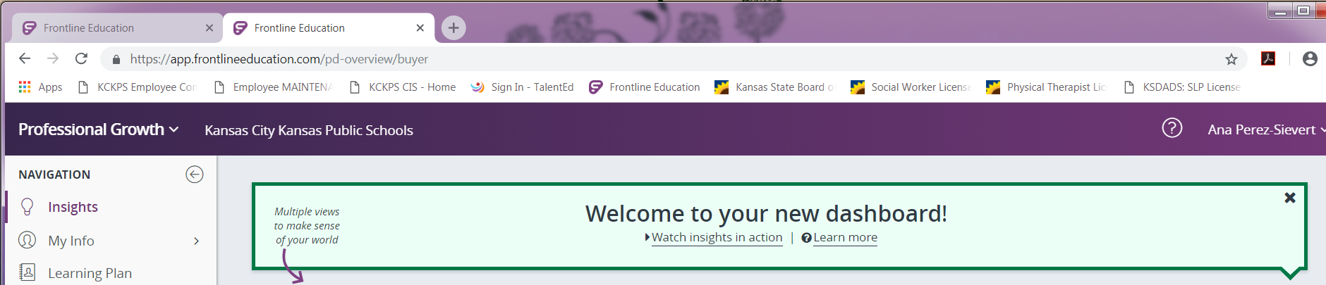
Step 11- Select the window with Synch Status option and click “Synch Status”
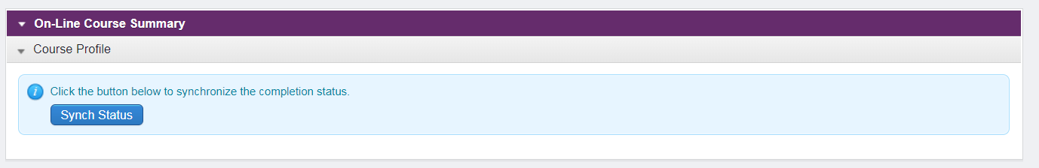

To return and continue the course follow steps 7- 9 From “Learning Plan”
Step 12- Click “Take Test”
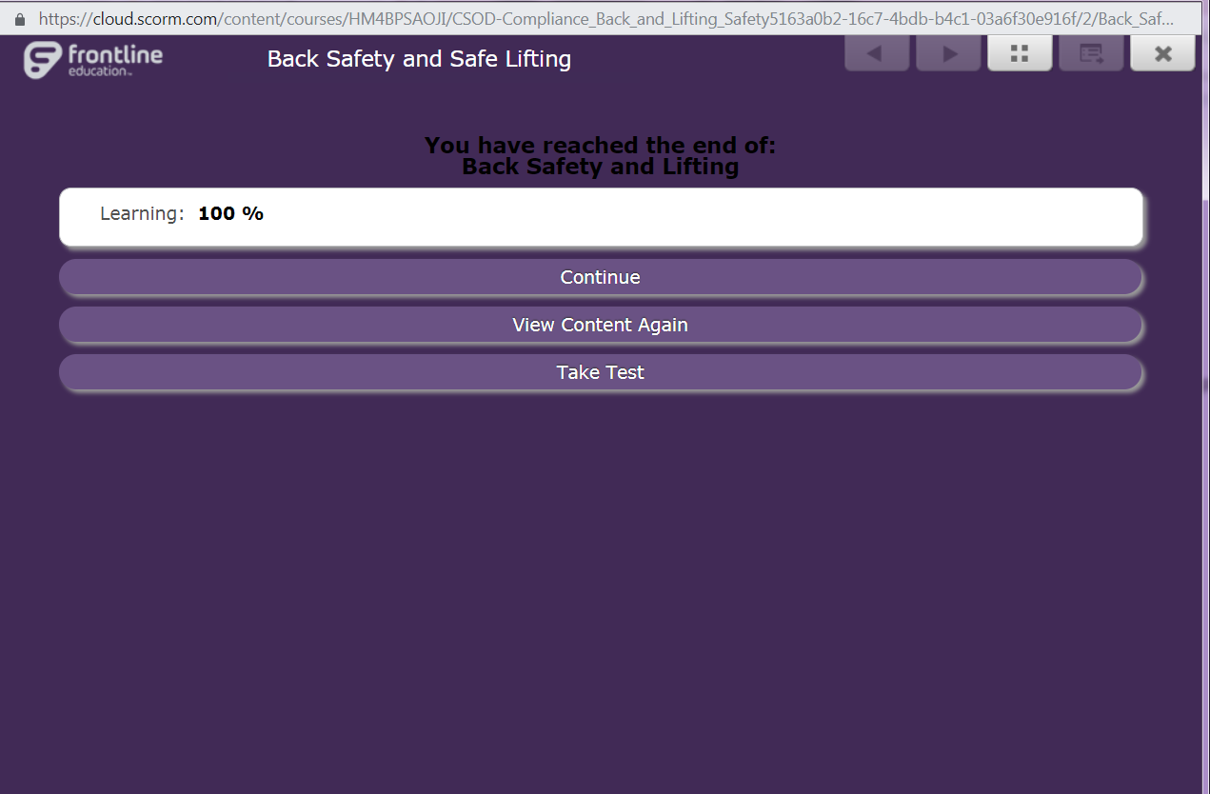

Step 13- Once passed, click “Exit”
Step 14- Click “Synch Status”

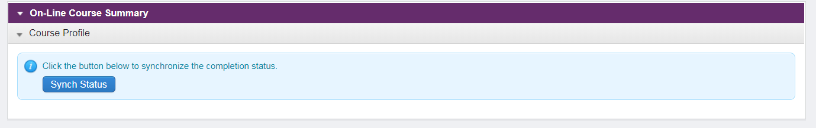

Step 15- If course has been completed, you will need to click on Mark Complete
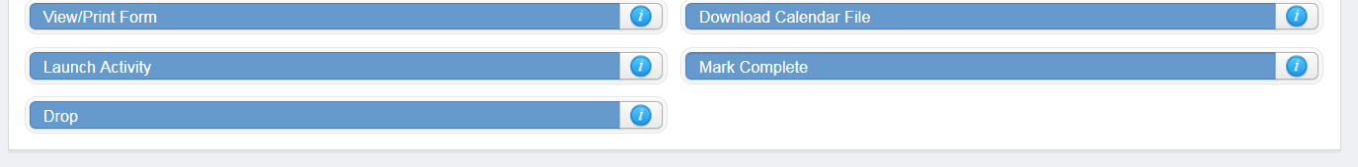

Note: You will be able to mark complete only when you successfully passed the test.

