● Feb. 2 | 30%
● Mar 2 | 50%
● Mar 30 | 75%
● April 20 | 90%
● May 18 | 100%

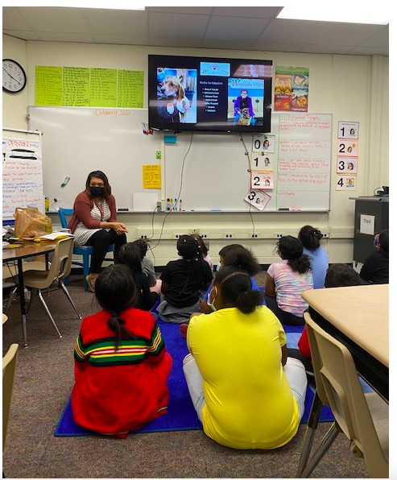
Spring 2022 Elementary Connector Goals
Goal: EVERY K-5 and elementary counselor will hold 1 live Connector session this semester.
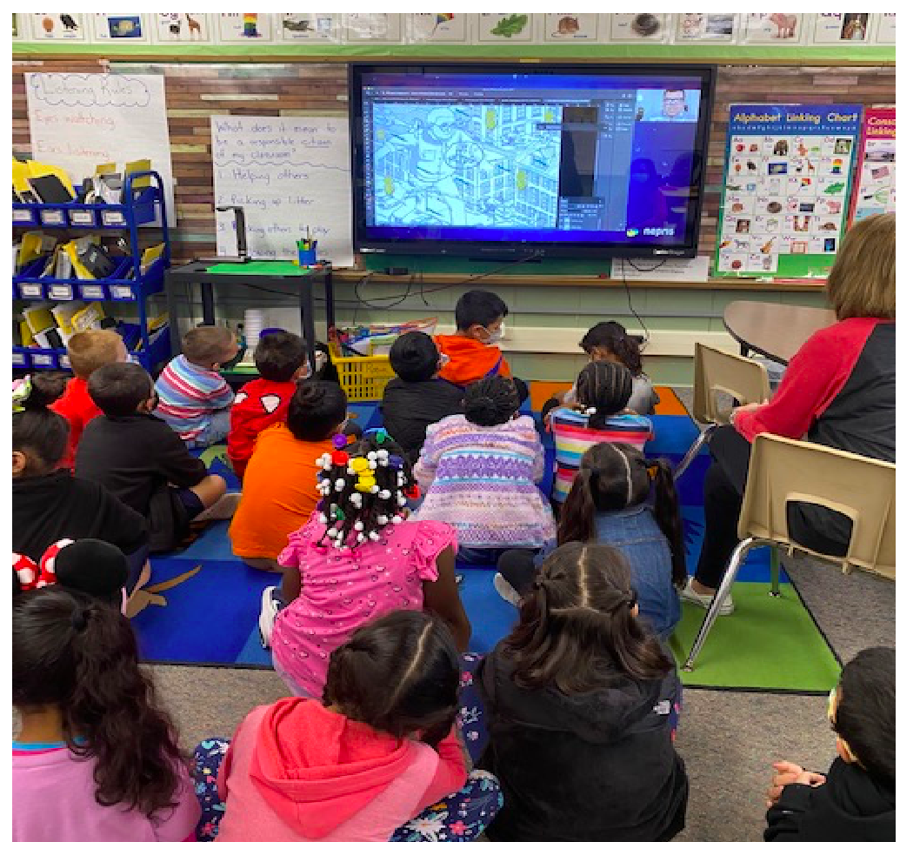
Progress Goal Dates:

All live session requests must be submitted by March 29
Requirement: EVERY elementary teacher will share a live Connector session or a recorded Connector video with their students during their FA times the week of:
- Feb. 7
- March 7
- April 4
- May 2

