- Login to Infinite Campus Instruction and navigate to the Standardized Test menu on the left side
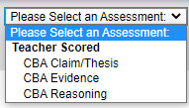

- Choose the term and the course you are going to enter scores for. In this example is a Quarter 3, Ancient World History 6 course.
- From the drop down Assessment Menu, choose the first score you want to enter.

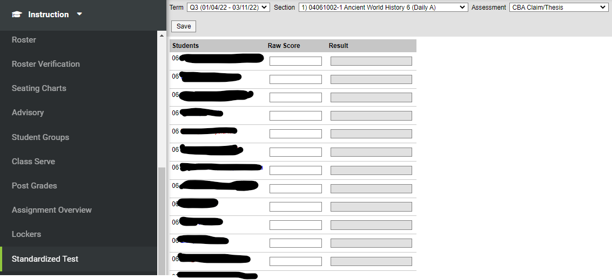
- Enter the score 1-4 (following the rubric) on the CBA Claim/Thesis part of the project, then click the Save Button
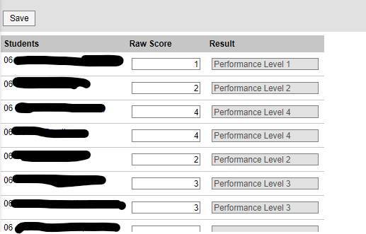

- After you Save, the performance level will appear in the Result Column. Repeat for the CBA Evidence and CBA Reasoning scores for each section of social studies you teach.

