Directions on How to Revisit Student’s ILP in Infinite Campus for 2nd Semester
In the Spring (April/May) for Codes 1, 2, 4, & 5 (DO NOT Re-Update Previous ILP)

1. Log into Infinite Campus
2. Click on Search, select Student from the dropdown list and click go or hit enter.
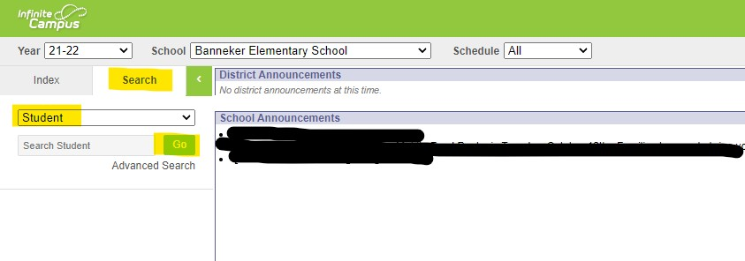

3. Select an ESL student from the list.
4. While you’re on the student’s record, click on the Index tab (top left side – next to Search).
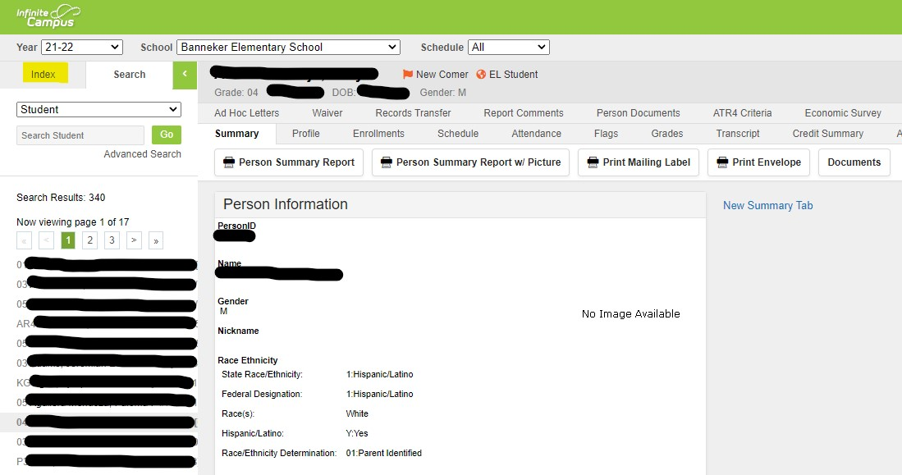

5. Under Student Information, scroll down to PLP and click on PLP, then click on General.
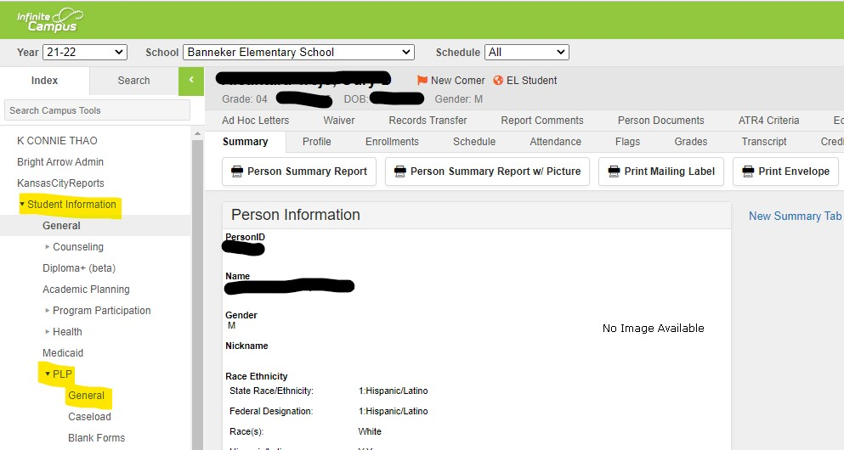

6. Click on the Documents tab
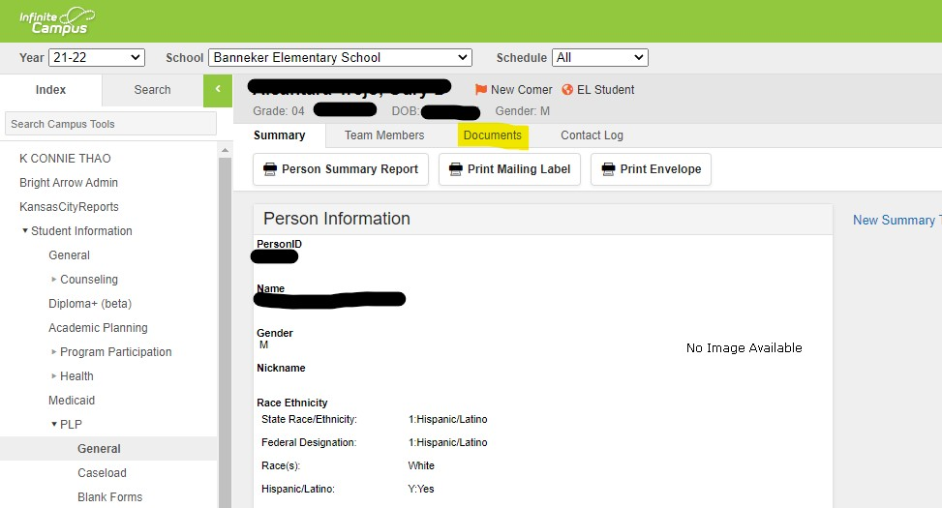

7. Double click on the Individual Learning Plan for the current school year or
highlight and click Open (next to the green box with a right arrow)
(Make sure you select the ILP for the current school year)

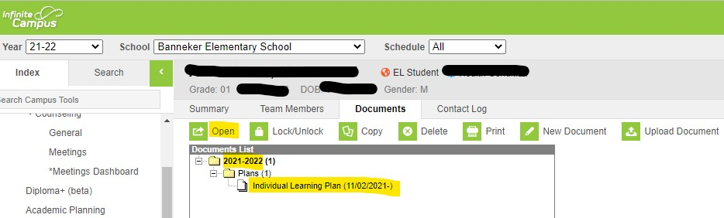

8. Under Education Plan:
- End Date: Enter the last day of school (same date as the Services end Date - May)
- Click Save (next to green box with a floppy disk)

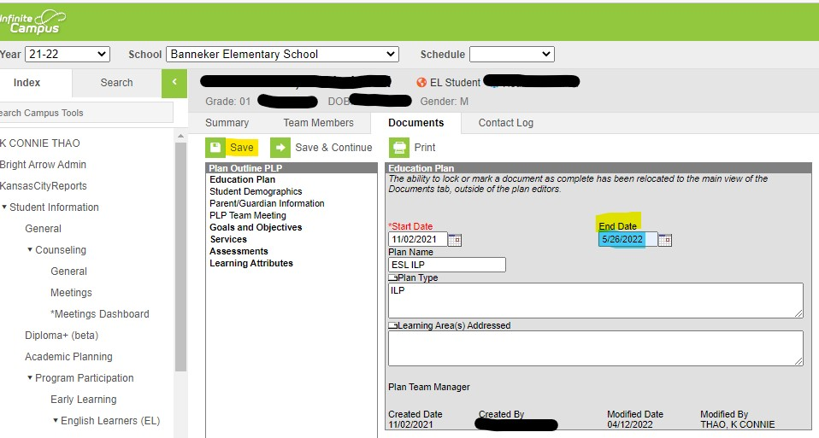

9. Once you save it, click on Goals and Objectives to the left, click on New Goal (next to the green
box with a + sign).
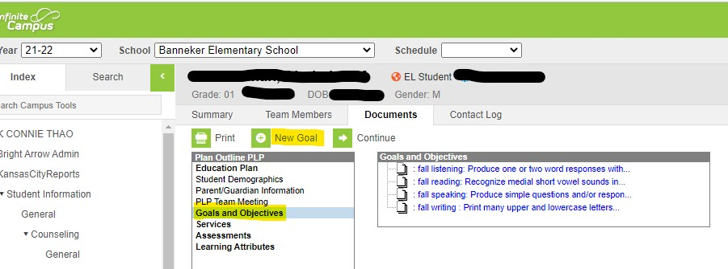

Under Goal Editor:
- Goal Name: Enter Spring Listening, Spring Reading, etc. (domains - in the Spring April/May)
- Goal: Click on the folder next to the word Goal, you will see a new screen
- Click on the + (plus sign) next to the folder and the word Goals, you will see the goals, scroll down (if the student achieved their goals, then select the next goal) according to student’s grade and level (if you pick a wrong goal, select everything in the goal box and hit delete)
- Click Save (next to the green box with a floppy disk)

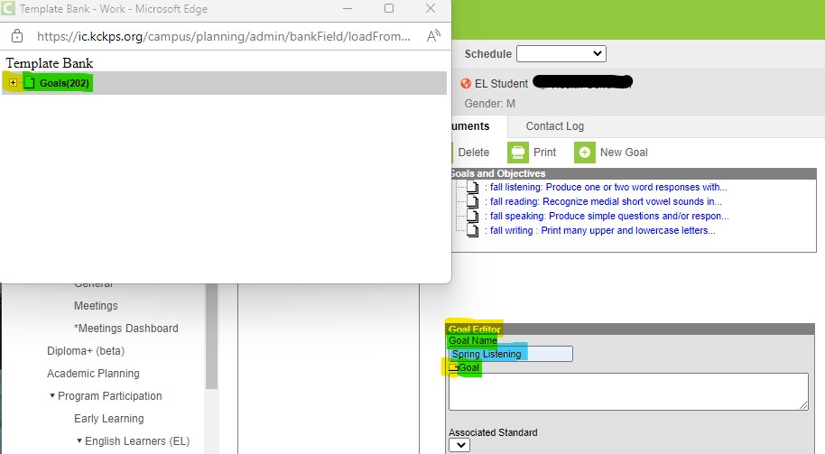

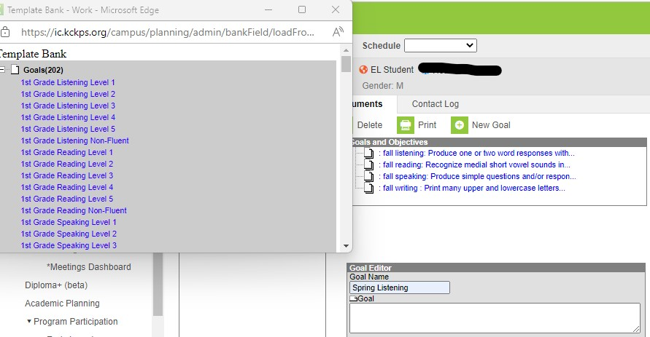
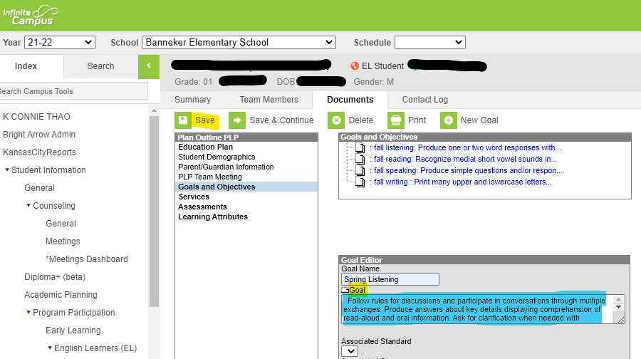

** Repeat the above steps for the remainder of the domains

10. To view or print the ILP
- Click on the Documents tab
- Select/click on the Individual Learning Plan, then click on Print (next to the green box with a printer), you will see a new screen with the ILP information.

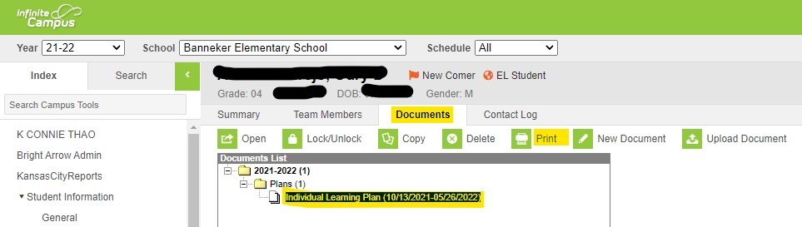

If you have any questions, please feel free to contact Connie Thao via email at connie.thao@kckps.org or at 627-4387.

Thank you SO much for all you do!!!

