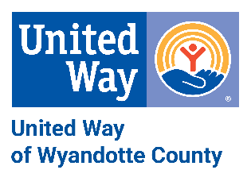

FROM WHY TO WY! Your support changes lives!

THANK YOU for your partnership with United Way of Wyandotte County! We appreciate your support and the dedicated staff members in your building that each year coordinate the UWWC campaign. USD 500’s United Way campaign is a vital element to the success of UWWC being able to continue the work we do with our partner agencies providing crucial programs to those in need in our community.

The students in your building are certainly an inspiration to all of us at UWWC. Our youth learn by those who lead them, and your staff has inspired a desire for giving in your students through their action of supporting UWWC and giving back to their community.

Again, we thank you for your continued support and for welcoming us into your building. We look forward to working with you and your staff during the upcoming 2018 United Way campaign.

With gratitude,

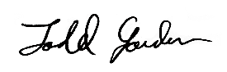 Gina McCord

Todd Jordan, PhD Gina McCord
President/CEO Director, Resource Development

